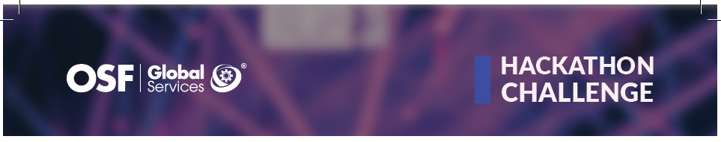

**Last Minute**

# Team Members:

1. Pavel Sebastian-Ionut

2. Burduniuc Daniela

3. Belu George-Cristian

# Team Lead:

**Pavel Sebastian-Ionut**

**Phone:** 0754312113

**Email:** pavel.sebastian.ionut@gmail.com

# Bitbucket:

**Link\***: https://bitbucket.org/osfglobalservices/lastminute

**Master Account**: lastminute@osf-global.com

**Master Account Password**: KR615OD910M

*\*Please use the master account to invite the rest of the team members*

# Windows Server Machine:

**Link:** lastminute.hackathon.osf.global.com

**Account:** lastminute

**Password:** KR615OD910M